`
Vulcan Activity Tracker
Weekly Report

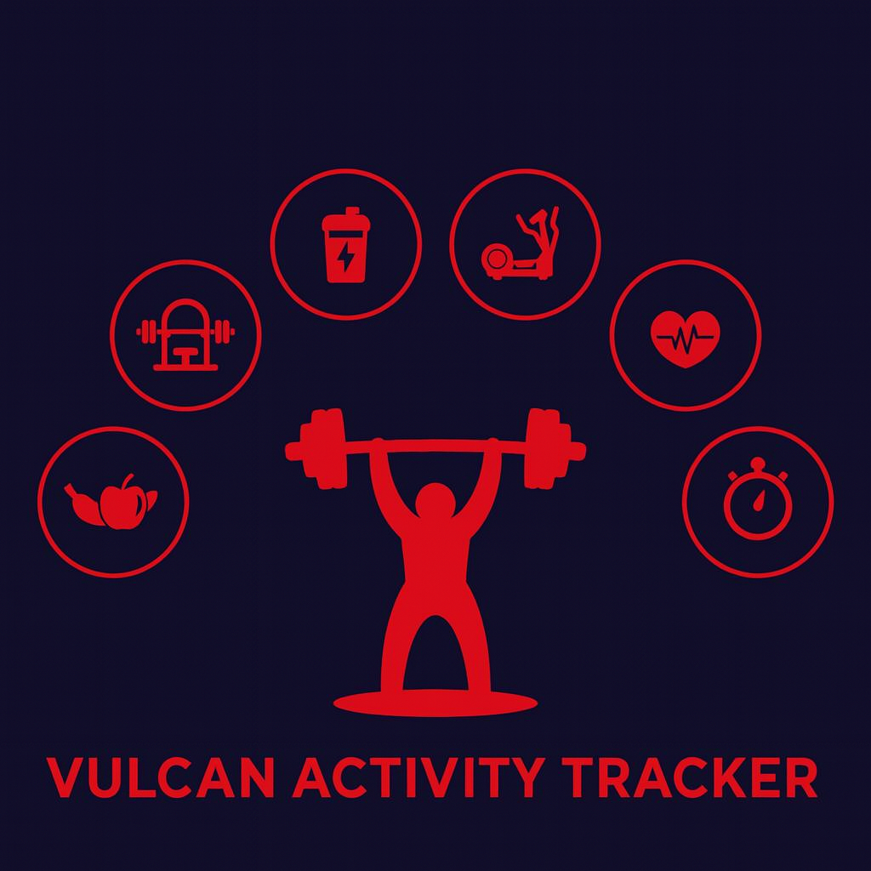

Week 8
Team Members:
Margo Bonal
John Gerega
Luke Ruffing

Professor: Dr. Weifeng Chen

Course: CMSC-4920-Senior Project II
School: Pennsylvania Western University

Table of Contents

Project: Vulcan Activity Tracker 2
Goals Accomplished: 2
Challenges Faced: 4
Solutions: 4
Team Progress: 5
Gantt Chart: 7
Week 8 Plan: 7
Member Contribution: 8
References 8

Project: Vulcan Activity Tracker
To complete the proposed goals in previous week’s report, our team followed a strict schedule of daily progress and communication. Our team had 4 main goals to complete, which included implementing a feature that ensures a user is logged in before they can access the dashboard, opening up our program to users for initial beta testing, work on a recovery email feature, and continuing development of both the challenges and teams page. Additional goals included initial development of the maps page. Since each goal needed time allocation for development and testing, we assigned each goal priority based on how they were connected to each other. Throughout the discussion, we decided that not allowing access to the tracker before a user is properly logged in was the main goal of this week. Achieving this goal will help keep the privacy of our tracker.

Goals Accomplished:
The first goal accomplished was implementing a required login that prevented users from simply redirecting to the site by typing /dashboard. Now, users must log in using their credentials before they can access our dashboard, activities, leaderboards, clubs, etc.
The second goal accomplished was user testing. We had users create accounts and run through each aspect of the program. Feedback was placed into the user feedback document. Users brought up changes we know we have to make and changes that we had no idea needed fixing. One of the main ones was to verify logins and create accounts better. For example, if a user has no credentials in our database but tries to log in, we should alert them, telling them that no such credentials exist.

The third goal that was accomplished was finding an application for recovery emails. Through various research, we found the application Resend. We felt that Resend was best, as with the free tier of the software, we get a daily limit of 100 emails and a monthly limit of 3,000 emails. We created an account
The fourth goal accomplished this week was the further development of the challenges page. A user can now join and leave challenges; a user can also delete a challenge if they are the creator of the challenge. Users can now also view individual challenge details page that will display the challenges description, participant count, and more.
Initialization of the maps page was the final feature and fifth goal of week 7. Considerable team time was spent to research and find the best free option of Map API. We needed this to connect our Vulcan Tracker to an internet map viewer such as the google maps viewer. Since our project remains on tight budgeting and senior project scale, it was both important and required to find a free student accessible version. An open-source option was found, Leaflet (2025). This is a JavaScript library available to developers for free with no additional fees or account creation. Simply including web API link at the top of our files, we were able to use this site’s documentation to build an interactive map feature. Leaflet presented a learning curve since the map feature requires coordinates to be entered. Through careful testing, our team formulated a system of storing these coordinates in arrays to be stored and used later.
Users can now plan outdoor exercise route. They can view premade routes stored in the Vulcan Activity Tracker or they can draw their own route on the map. These routes are then stored by the name the user entered and linked to their user id. This allows routes to be displayed when the user logs back into the app or moves between platform pages. Careful design considerations went into this map feature. As a user draws a path, markers are displayed to show where the user clicked, however, upon saving the route, the markers are removed to show the completed path. The map feature is additionally set to the initial coordinates of PennWest California campus. The view can be zoomed in or out to show different locations, however, our university is the primary location for the map and overall student use case. Map markers display information for users to view.

Challenges Faced:
(Number aligns with its solution below)
- Rerouting difficult to fix since pages are dynamically loaded
- Use of local host is insecure
- Email Password Recovery Backend – While we successfully found a site for email sending in Resend and implemented a frontend page to request an email to reset a password, we are still having a server error on the backend. Through lots of debugging, we still haven’t quite nailed down the issue yet, but this will be one of the main goals for this upcoming week.
- Conflicting CSS style declarations

Solutions:
1. Ensuring that users are not able to route past the app’s login right to the dashboard was quite difficult. A Wrapper function called login_required was initialized. It locks down all page routing until a valid user id enters the login session. Each API is then wrapped in this function to block any functionality. Additionally, every dynamic page route is set to private. The only pages that can be viewed without app entry are the welcome and login pages. Upon logout, the user id is removed from session storage to ensure that the application is locked again. This solution was of great precedence since it ensures user and app safety.
2. A solution to the use of local storage came along with the securing of routes. User session storage was finally implemented. This means that the user that logged in, their username is stored on the server side of the platform instead of the client side. Removing the use of local storage eliminated the ability of the Cross Site Scripting attack (XSS), when an attack injects malicious code into an applications JS or HTML to retrieve data. This week 7 revision moved our app towards cybersecurity compliance.
3. Email Password recovery still remains unsolved. However, considerable progress has been made on research, initial setup of UI entry fields, and server-side logic.
4. Renamed some of the CSS styles to better match what they are used for and to stop the confliction

Team Progress:
Throughout week 7 our team has made substantial progress to the Vulcan Activity Tracker. According to our Gantt chart our team is still on schedule for many parts of the project. One of the primary goals accomplished this week was implementing a required logged in feature that prevents users from bypassing user authentication by manually type in URLs like “/dashboard”. This feature itself greatly improves the security and integrity of our project.
Another major step forward was conducting user testing. We had multiple users create accounts and go through the activity trackers various features including activity tracking, leaderboard, clubs and challenges. The feedback from the test group was documented and compiled in a user feedback file that our whole team has access to. We believe although we are still months away from our tracker being a finished product, user testing is an extremely important and valuable process. This is because getting users without biases or technical knowledge to run through a program exposes issues the developers might not have previously considered. For example, one test user suggested a feature that has the users confirm the password they chose while making an account, a simple feature used is many applications to ensure the user didn’t accidentally mess up their wanted password, but for us developers who just want to log on to the application as fast as we can to test other features, we never thought of it.
Additionally, after much research our team found a service email provider that can be used to implement a password recovery feature. After evaluating many options for an email provider, our team landed on Resend as the best application for our needs. We determined this because Resend allows us up to 100 emails per day, and 3,000 emails per month, for free, which for our estimated user base will work perfectly.
The last accomplishment of this week was the continued development of both our challenges and teams pages. The development of both is moving at a slow but steady pace as we are trying to link the activity data and the frontend to present users with a dynamic UI that gives them their data in ways that improve clarity and organization.

Gantt Chart:
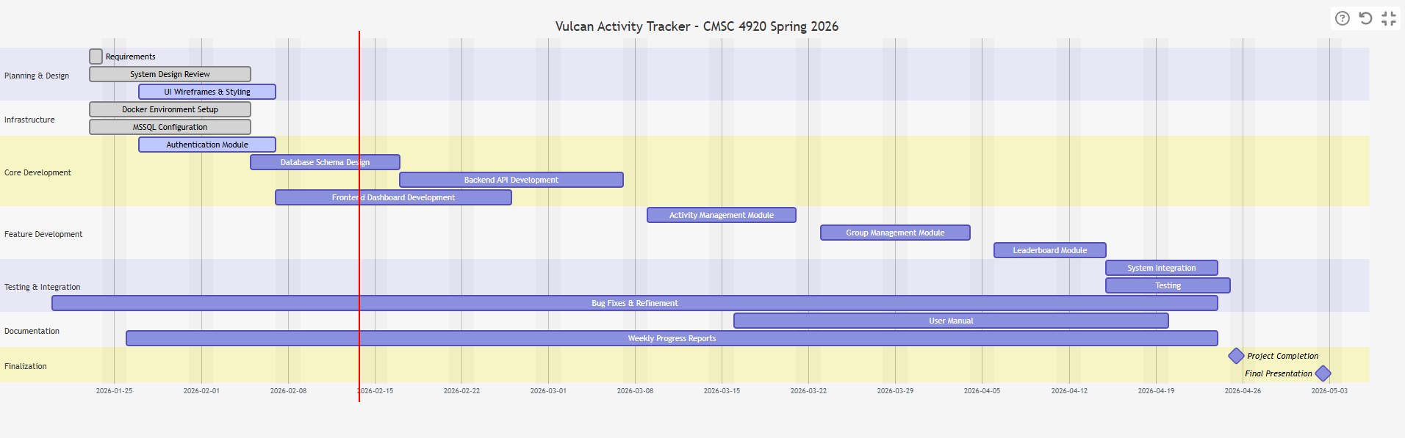

Week 8 Plan:
Our week 8 plan is going to focus on getting these recovery emails up and working. We also want to consider our user feedback and begin making those changes, with some of them already being completed. One of those features is the User Profile Section, which would also allow us a chance to implement a delete account feature that was also requested by the user. We also want to continue to improve the pages that are developed, with some of them still having minor bugs in them. We also want to add additional features to the Maps page, such as delete route.

Member Contribution:

Team Members
Margo Bonal: | - Team meetings, Week 7 Report & Slides, Maps page, User Authentication, Maps Page, Database/API logic, research
John Gerega: | - Team meetings, Week 7 Report & Slides, Teams page, Password recovery, research
Luke Ruffing: | - Team meeting, Week 7 Report & Slides, Challenges page

References

Agafonkin, V. (2025, Aug 16th). Leaflet.
https://leafletjs.com/
OpenStreetMap. (2025). OpenStreetMap.
https://www.openstreetmap.org/copyright

